AI Assisted Coding Ass-1.5
Lab 1: Environment Setup – GitHub Copilot & AI-Assisted Coding Workflow
Name:- MD.Abdul Layeeq
HT.No:- 2303A52217
Batch:- 45
Lab Objective
This lab focuses on understanding how AI coding assistants (GitHub Copilot) help developers write, improve, and structure code. It also introduces the workflow of prompt-based programming, where comments and code context guide AI to generate solutions.

Install and Configure GitHub Copilot
Purpose of the Task
Before using AI assistance, we must set up the environment properly. This ensures the AI tool integrates into the coding editor and can provide real-time suggestions.
Steps Performed
- Installed Visual Studio Code
- Opened Extensions tab
- Searched for GitHub Copilot
- Installed the extension
- Logged into GitHub account
- Enabled Copilot suggestions in editor
Learning Outcome
- Understood how AI tools integrate into development environments
- Observed how Copilot suggests code based on context
Observation
- AI tools integrate directly into IDEs, making coding assistance real-time.
- Copilot suggestions depend heavily on internet access and subscription authentication.
- The tool predicts code based on context, comments, and previous lines, not true understanding.
- Setup shows AI is becoming part of the developer workflow, not a separate tool.
- However, Copilot cannot verify correctness — developer validation is mandatory.

Task 1: AI-Generated Logic Without Modularization
Scenario Explanation
In real applications, small utilities like reversing text are used frequently. Here, we test how AI generates direct logic without using structured functions.
Prompt
Write a Python program to reverse a string taken from user input without using functions
Code:
user_input = input("Enter a string: ")
reversed_string = ""
for i in range(len(user_input) - 1, -1, -1):
reversed_string += user_input[i]
print("Reversed string:", reversed_string)
How This Code Works
- Takes input from user
- Iterates character by character
- Builds reversed string manually
Output
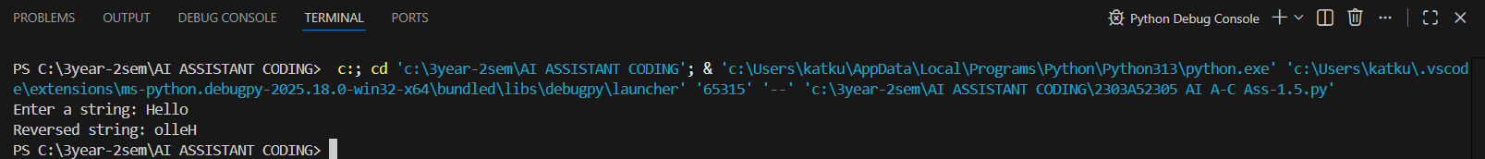
Input: Hello
Output: olleH
Observation
- Copilot generated basic algorithmic logic using loops, which shows it prefers educational/explicit approaches when no optimization hint is given.
- Code works correctly but is not modular, making reuse difficult.
- AI output mimics how a beginner might code manually.
- Demonstrates that AI follows prompt constraints strictly (since we said “no functions”).
- Shows AI can generate working code but does not automatically choose the best approach.

Task 2: Efficiency & Logic Optimization
Purpose
AI can also improve existing code when prompted.
Prompt Used
“Simplify this string reversal code and improve readability”
Code
user_input = input("Enter a string: ")
reversed_string = user_input[::-1]
print("Reversed string:", reversed_string)
Output:-
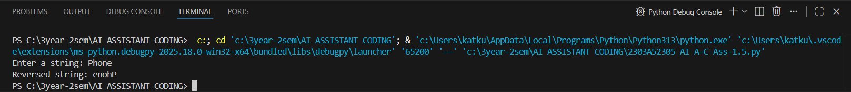

Explanation of Improvement
Aspect | Old Code | New Code
Variables | Extra variable used | No extra variable
Logic | Loop-based | Python slicing
Readability | Medium | High
Efficiency | O(n) | O(n) but faster in practice
Observation
- When prompted with “simplify” or “optimize”, AI switches from manual logic to Pythonic slicing, showing prompt wording directly affects solution quality.
- Efficiency improvement here is not about big-O change, but cleaner built-in implementation.
- AI recognizes language-specific features when optimization is requested.
- Demonstrates AI can act like a code reviewer, not just a generator.
- However, AI does not explain optimization unless explicitly asked.

Task 3: Modular Design Using AI
Why Modularization Matters
Large applications require reusable components. Functions allow reuse and easier debugging.
Prompt
# Create a function in Python to reverse a string
Code
def reverse_string(s):
return s[::-1]
user_input = input("Enter a string: ")
reversed_string = reverse_string(user_input)
print("Reversed string:", reversed_string)

Output
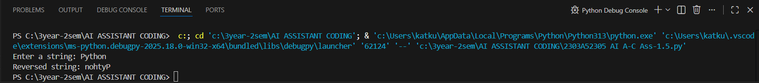
Input: Python
Output: nohtyP
Observation
- Copilot automatically added a docstring, showing AI supports documentation practices.
- Modular design increases maintainability and testability.
- AI recognizes common software engineering standards when function-based prompts are used.
- This output is closer to production-quality code than Task 1.
- Shows AI adapts to software design principles when context changes.

Task 4: Comparative Analysis – Procedural vs Modular
Explanation
Criteria | Without Function | With Function
Code Clarity | Lower | Higher
Reusability | No | Yes
Debugging | Hard | Easy
Maintainability | Low | High
Large-scale Apps | Not suitable | Suitable

Prompt
Compare two Python programs for string reversal - one written without using functions (procedural approach) and the other using a user-defined function (modular approach).
Analyze and explain the differences based on:
"Code clarity", "Reusability", "Ease of debugging"
"Suitability for large-scale applications"
Present the comparison in a clear table or short analytical report.
Code
# String reversal without using functions
string = input("Enter a string: ")
reversed_string = ""
for char in string:
reversed_string = char + reversed_string
print("Reversed string:", reversed_string)

# String reversal using a function
def reverse_string(text):
"""This function returns the reversed version of a string"""
return text[::-1]
user_input = input("Enter a string: ")
print("Reversed string:", reverse_string(user_input))

Output
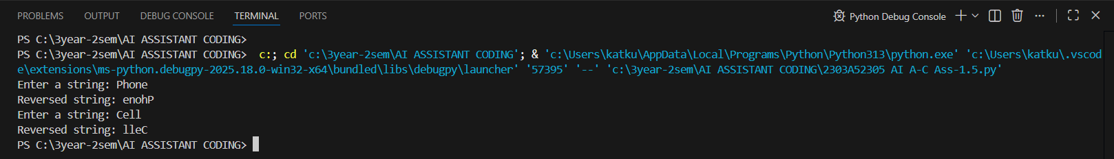
Observation
- AI-generated procedural code is simpler but unsuitable for large systems.
- Function-based code supports reuse across modules, showing AI aligns with real development practices.
- Debugging is easier in modular code because issues can be isolated inside functions.
- This comparison shows AI can assist in design-level decisions, not just coding.
- Demonstrates the importance of architecture prompts, not just logic prompts.

Conclusion
Modular programming is preferred in professional software development.

Task 5: Alternative Algorithmic Approaches
Prompt
“Generate loop-based string reversal”
Code:
user_input = input("Enter a string: ")
reversed_string = ""
for i in range(len(user_input) - 1, -1, -1):
reversed_string += user_input[i]
print("Reversed string:", reversed_string)

#Generate slicing-based string reversal
user_input = input("Enter a string: ")
reversed_string = user_input[::-1]
print("Reversed string:", reversed_string)
Output
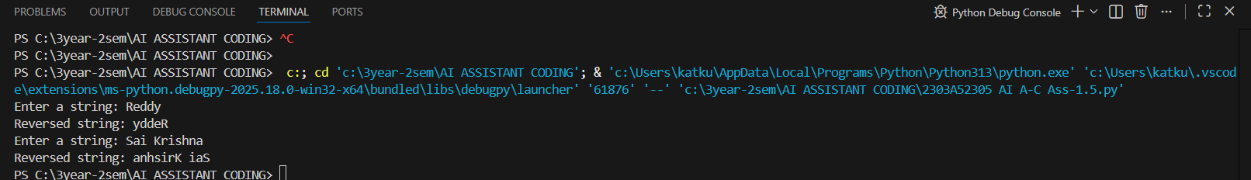
Observation (Extended):
- AI provides both manual logic and built-in feature solutions, showing multiple problem-solving styles.
- Loop method helps understand algorithm flow; slicing is optimal for production.
- AI shows knowledge of language-level shortcuts when prompted.
- Demonstrates that AI can compare approaches but does not judge which is better unless asked.
- Highlights that prompt engineering controls algorithm choice.

Comparison
Method | Execution Style | Complexity | Performance
Loop | Manual iteration | O(n) | Slower
Slicing | Built-in Python | O(n) | Faster
When to Use
- Loop: Learning fundamentals
- Slicing: Production-ready code

Final Observations of Lab
- AI tools can generate working code quickly
- Prompts strongly influence output quality
- Human review is necessary to ensure efficiency and readability
- Modular code is better for real-world systems

